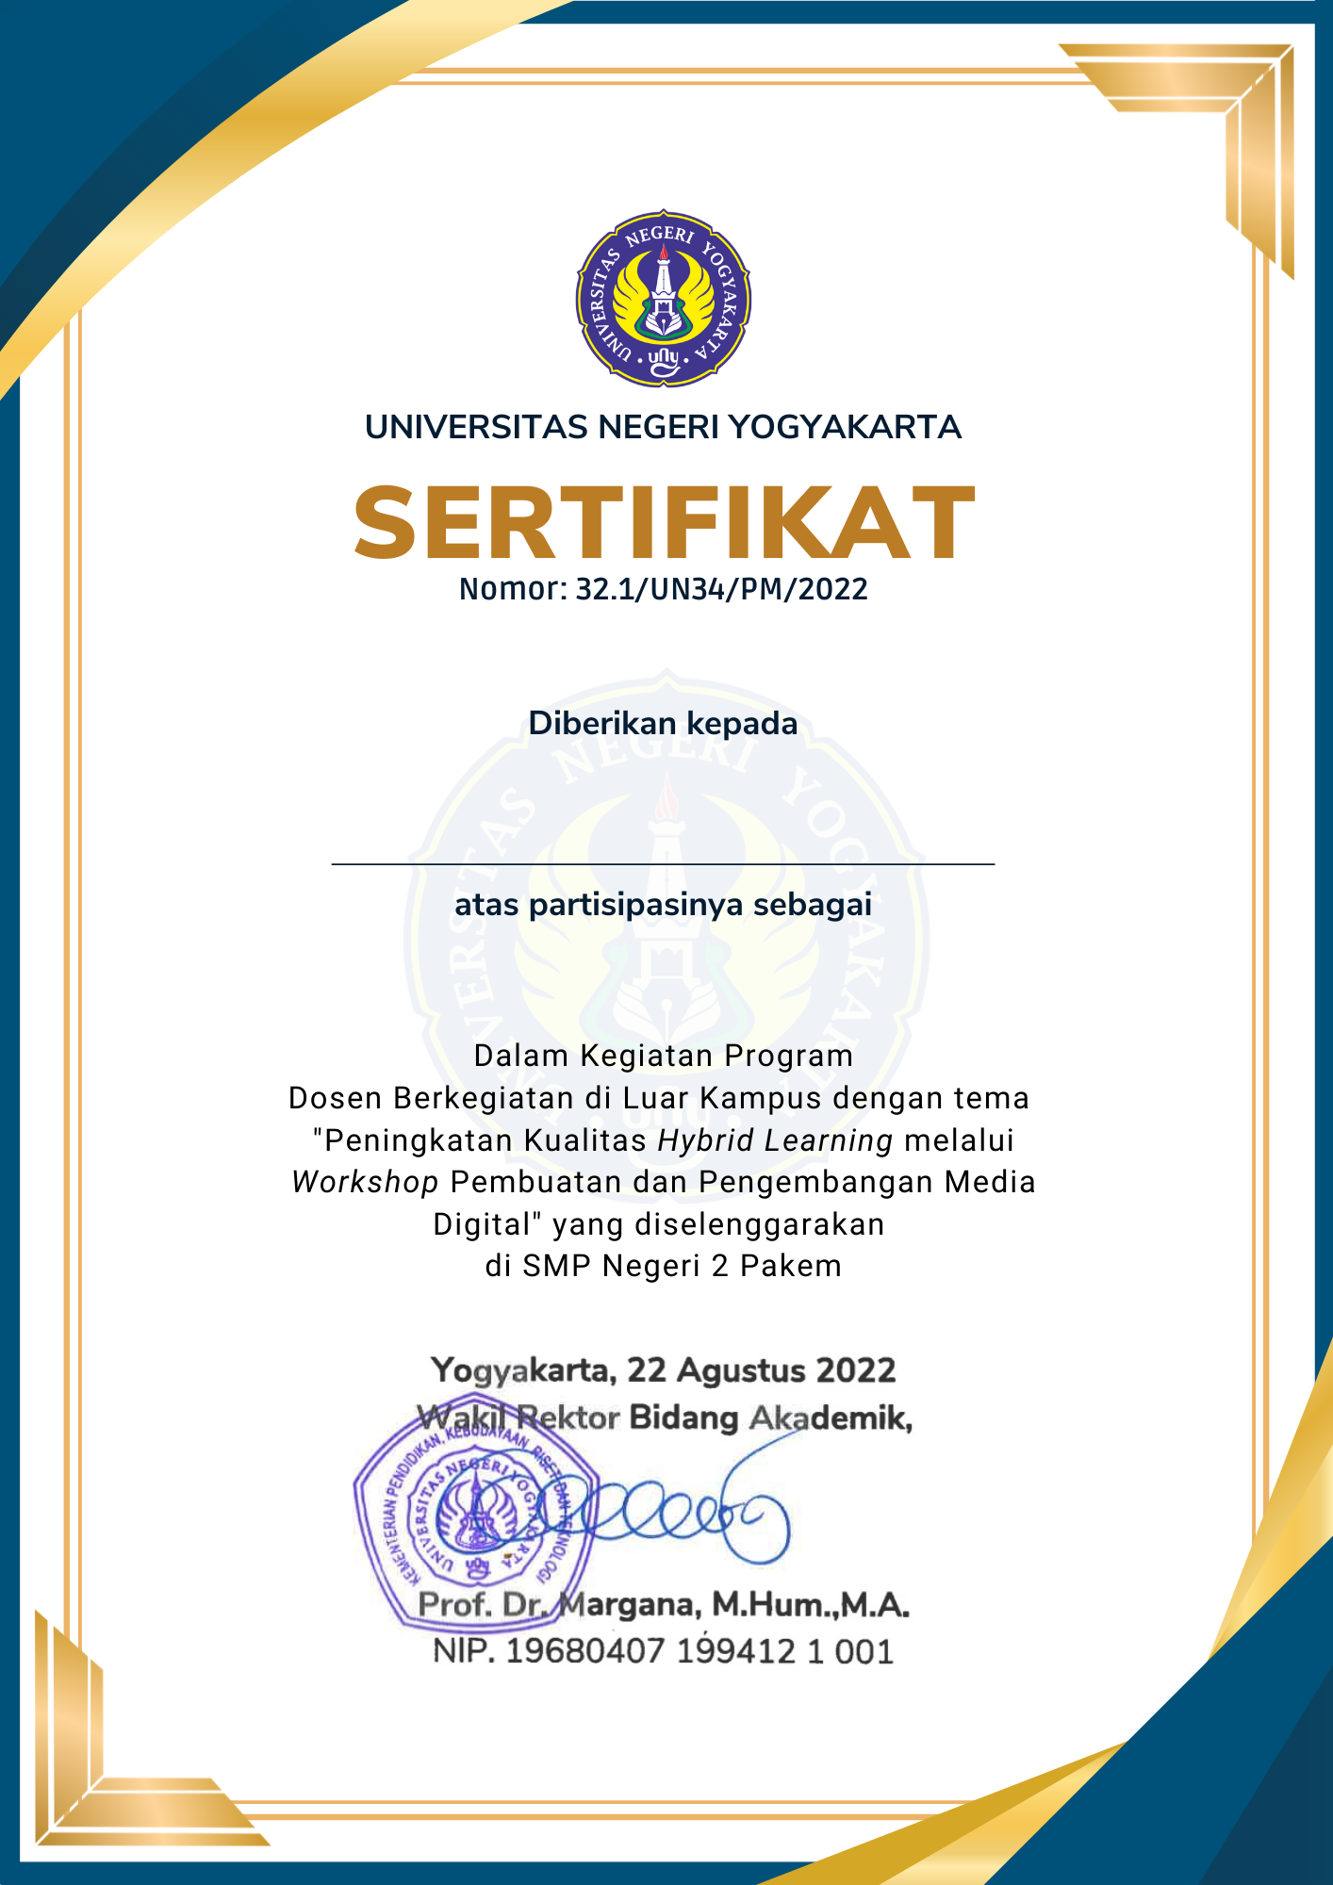**Muhammad Ghazi Alghifari**

**Pemateri**